SYSTEM ARCHITECTURE
- Architecture Type:
The system follows a three-tier architecture to ensure scalability, security, and easy maintenance.
- Presentation Layer
- Web interface for Customers and Admin
- Handles user interaction and data input
- Application Layer
- Business logic and processing
- Handles orders, payments, reservations, and authentication
- Data Layer
- Centralized database
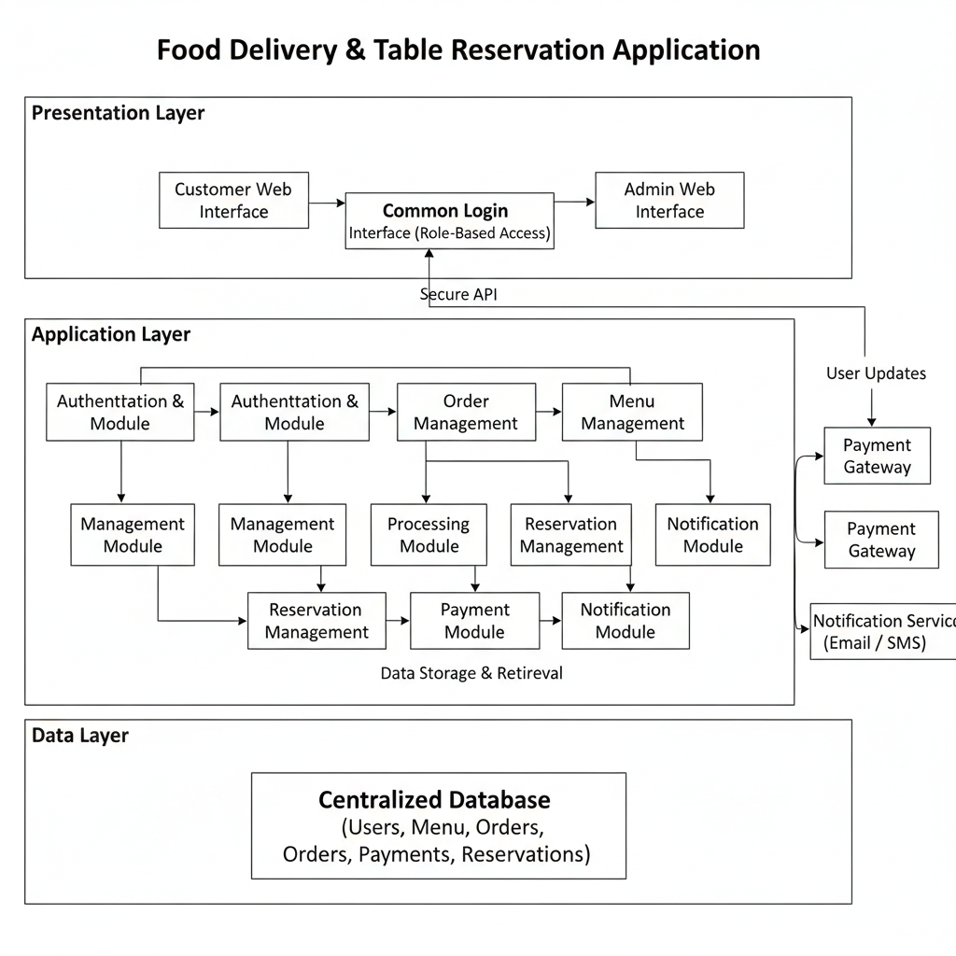
- Stores user details, menu items, orders, payments, and reservations
MODULE DESCRIPTIONS
1. Authentication Module
  - Common login system for all users
  - Role-based access (Customer / Admin)
  - Secure user authentication
2. Customer Module
  - Browse food menu
  - Add items to cart
  - Place food orders
  - Make online payments
  - Track order status
  - Reserve tables
3. Admin Module
  - Manage menu items
  - View customer orders
  - Update order status
  - Manage table reservations

- Menu Management Module
  - Add, update, and delete menu items
  - Manage item availability and pricing

- Order Management Module
  - Process customer orders
  - Maintain order lifecycle
  - Update order status

- Payment Processing Module
  - Integrates online payment gateway
  - Handles payment confirmation and failure
  - Ensures secure transactions

- Reservation Management Module
- Handles table booking requests
- Checks availability
- Confirms or rejects reservations

